I**NDEX**

1. Description of Project
2. Project’s Flowchart
3. Code of Project
4. Output (screenshots)

**Small Organization Network Setup Report**

**Table of Contents**

1. Project Overview

2. Network Topology

3. Reason for Choosing Specific Hardware

4. IP Addressing Scheme

5. Network Setup Steps

6. Verification

7. Conclusion

**Project Overview**

* This report details the setup of a small organization's network using Cisco Packet Tracer. The network includes one main router, four switches, one server, and six end-user desktops.
* Each subnet has a designated gateway, and the server is configured as a DNS server. The network topology aims to ensure efficient communication and centralized management within the organization.

**Network Topology**

* Router: Cisco 2811 with an NM-2FE2W module for additional Fast Ethernet interfaces.
* Switches: Cisco 2960-24TT, each connecting to the router and designated end-user devices.
* Server: Configured as a DNS server.
* End-User Desktops: Six desktops distributed across three switches.

**Reason for Choosing Specific Hardware**

* Cisco 2811 Router: The Cisco 2811 is a versatile router suitable for small to medium-sized networks. It supports various interface modules and offers robust performance for routing and network services.
* NM-2FE2W Module: This module adds two Fast Ethernet interfaces, allowing the router to handle more connections and providing flexibility in network design.
* Cisco 2960-24TT Switches: These switches are ideal for small organizations due to their reliability, ease of management, and sufficient port density to handle multiple devices.

**IP Addressing Scheme**

* **Router Interfaces:**
  + GigabitEthernet0/0: 192.168.1.1/24
  + FastEthernet0/1: 192.168.2.1/24
  + FastEthernet0/2: 192.168.3.1/24
  + FastEthernet1/0: 192.168.4.1/24
* **Switches:**
  + Switch0: 192.168.2.1/24 (Connected to PCs with IPs 192.168.2.2, 192.168.2.3)
  + Switch3: 192.168.3.1/24 (Connected to PCs with IPs 192.168.3.2, 192.168.3.3)
  + Switch2: 192.168.4.1/24 (Connected to PCs with IPs 192.168.4.2, 192.168.4.3)
  + Switch1: 192.168.1.1/24 (Connected to Server with IP 192.168.1.100)
* **Server:**
  + IP Address: 192.168.1.100
  + Subnet Mask: 255.255.255.0
  + Default Gateway: 192.168.1.1
  + DNS Server IP: 192.168.1.100
* **End-User Desktops:**
  + Switch0:
    - PC1: 192.168.2.2/24
    - PC2: 192.168.2.3/24
* Switch3:
  + PC3: 192.168.3.2/24
  + PC4: 192.168.3.3/24
* Switch2:
  + PC5: 192.168.4.2/24
  + PC6: 192.168.4.3/24

**Network Setup Steps**

**Router Configuration**

**Cisco 2811 Router**:

Router> enable

Router# configure terminal

Router(config)# interface GigabitEthernet0/0

Router(config-if)# ip address 192.168.1.1 255.255.255.0

Router(config-if)# no shutdown

Router(config-if)# exit

Router(config)# interface FastEthernet0/1

Router(config-if)# ip address 192.168.2.1 255.255.255.0

Router(config-if)# no shutdown

Router(config-if)# exit

Router(config)# interface FastEthernet0/2

Router(config-if)# ip address 192.168.3.1 255.255.255.0

Router(config-if)# no shutdown

Router(config-if)# exit

Router(config)# interface FastEthernet1/0

Router(config-if)# ip address 192.168.4.1 255.255.255.0

Router(config-if)# no shutdown

Router(config-if)# exit

Router(config)# exit

Router# write memory

**Switch Configuration**

**Cisco 2960 Switches**

**Switch 0**

**Switch 2**

**Switch 3**

Switch0> enable

Switch0# configure terminal

Switch0(config)# interface vlan 1

Switch0(config-if)# ip address 192.168.2.1 255.255.255.0

Switch0(config-if)# no shutdown

Switch0(config-if)# exit

Switch0(config)# exit

Switch0# write memory

Switch3> enable

Switch3# configure terminal

Switch3(config)# interface vlan 1

Switch3(config-if)# ip address 192.168.3.1 255.255.255.0

Switch3(config-if)# no shutdown

Switch3(config-if)# exit

Switch3(config)# exit

Switch3# write memory

Switch2> enable

Switch2# configure terminal

Switch2(config)# interface vlan 1

Switch2(config-if)# ip address 192.168.4.1 255.255.255.0

Switch2(config-if)# no shutdown

Switch2(config-if)# exit

Switch2(config)# exit

Switch2# write memory

**Switch1:**

Server> Services > DNS

Turn on DNS service.

Add records (e.g., www.try.com -> 192.168.1.100)

Server> IP Configuration

IP Address: 192.168.1.100

Subnet Mask: 255.255.255.0

Default Gateway: 192.168.1.1

DNS Server: 192.168.1.100

**DNS Service Configuration:**

**Server Configuration**

**DNS Server Configuration: **

Switch1> enable

Switch1# configure terminal

Switch1(config)# interface vlan 1

Switch1(config-if)# ip address 192.168.1.1 255.255.255.0

Switch1(config-if)# no shutdown

Switch1(config-if)# exit

Switch1(config)# exit

Switch1# write memory

**Verification**

**Ping Test**

* Ping from each desktop to its respective gateway, the server (192.168.1.100), and other desktops within the same subnet to ensure connectivity.

**DNS Test**

* From any desktop, use the command:

nslookup www.try.com

* This should return the IP address 192.168.1.100, verifying the DNS server functionality.

**Conclusion**

This project provided hands-on experience with configuring and managing a small organizational network. By setting up different subnets, configuring a DNS server, and ensuring proper communication between all devices.

**Network:**

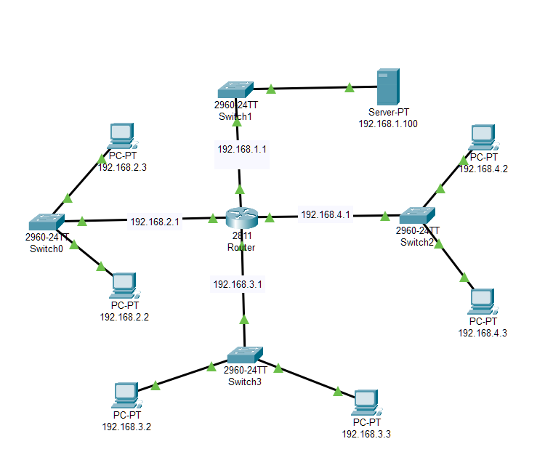

**DNS output**

